Co-Chair  Vernon Sykes, Representative  34th House District | 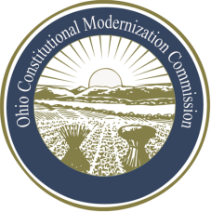 | Co-Chair  William G. Batchelder, Speaker  69th House District
Ohio Constitutional Modernization Commission

Constitutional Revisions & Updating

- Art. II, Sec. 1 (Legislative Initiative/Referendum)

- Art. XVI (Amendments)

- Initiative

- Referendum

